Epilog Zing 24 Laser
General Use Tutorial
This tutorial will guide you through the basic use of this equipment in Jumbo’s Maker Studio.

IMPORTANT NOTE

If you have any questions about the instructions or suggestions, please add a comment and the staff will update the tutorials. Your comments will help future users make better use of the equipment in Jumbo’s Maker Studio.
SAFETY WARNINGS
Only use approved material listed in Epilog Zing - Speed/Power Settings

Before setting up the Epilog Zing 24 Laser cutter, please make sure your file is set up properly for etching and cutting.  Follow the instructions in the document below:  Epilog Zing - Doc Setup | 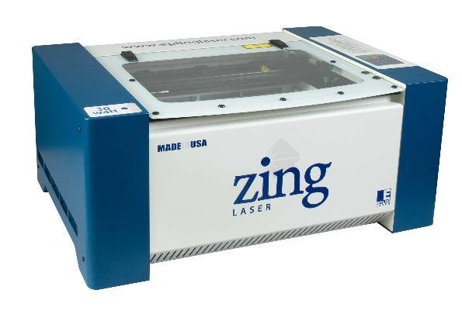
1) Open the top door of the laser cutter. | 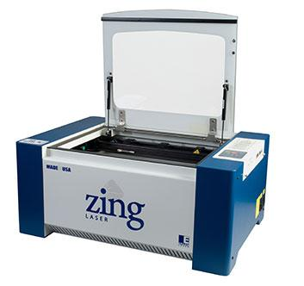
2) Select your material  Do not use PVC, Vinyl or Heavy Metal.  If you are unsure if your selected material is approved for cutting or engraving, check the list of Common or User Submitted materials in the document below:  Epilog Zing - Speed/Power Settings  Note: If you would like to add a material to the approved list, please contact a member of the Maker Studio staff. | 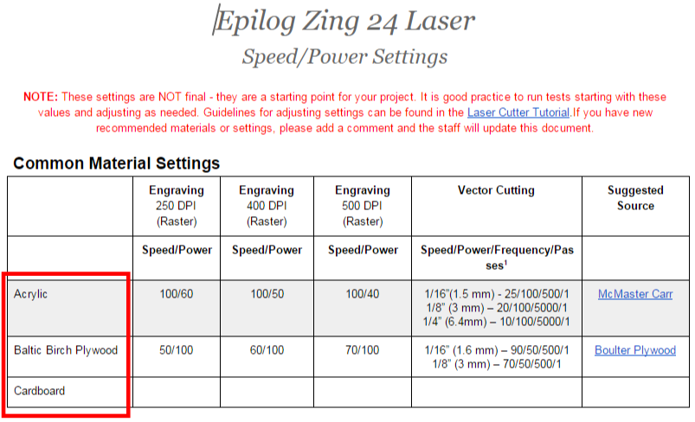  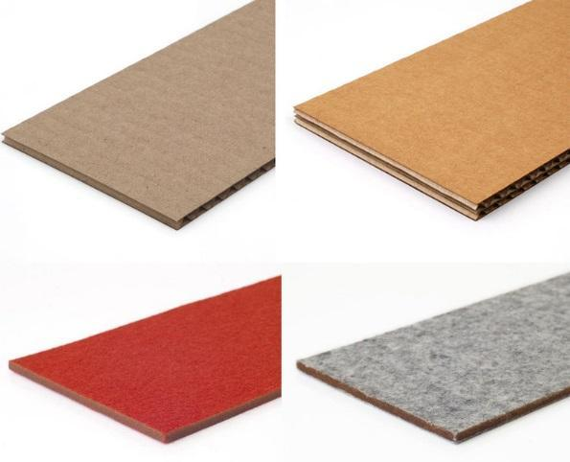
3) Place your selected material in the top-left corner of the laser cutter tray. Make sure it is tight against the rulers. | 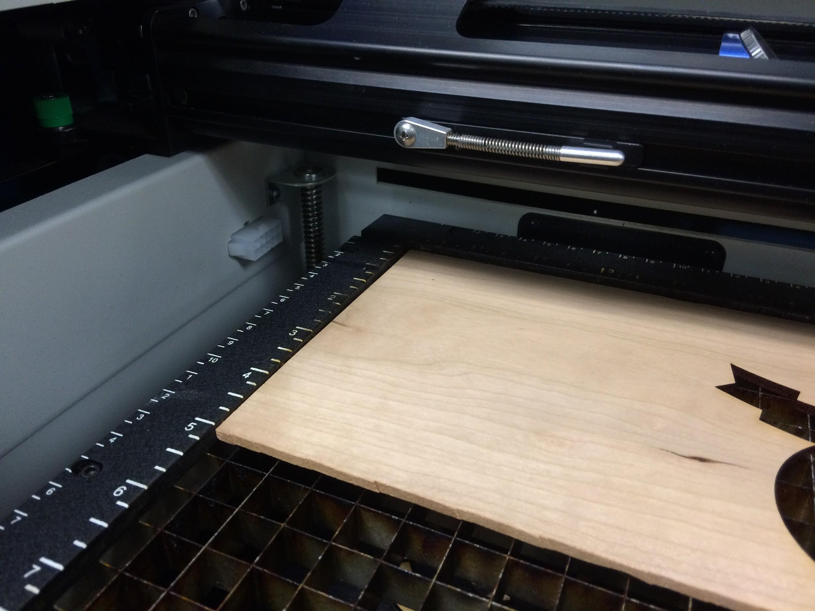
4. Turn on the laser cutter by pushing the switch located on the right side of the machine.  Wait for the laser cutter to stop moving before continuing onto Step 5. | 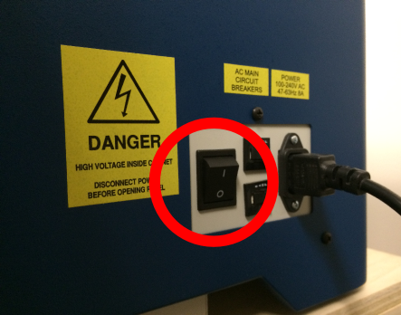
5) Prepare the Focus Gauge by pushing the Focus button on the Control Pad. | 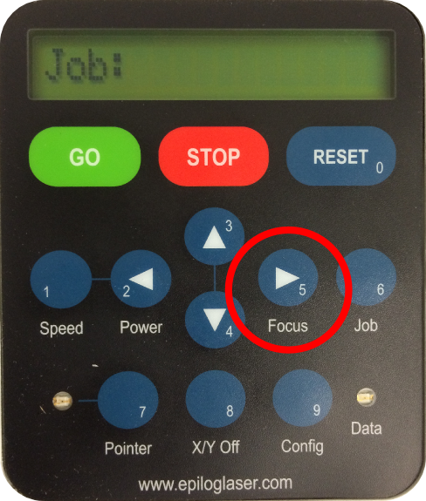
6) Locate the Focus Gauge on the horizontal beam. Release the Focus Gauge from its hook so that it hangs freely (not touching your material).  Note: If the Focus Gauge is touching your material, lower the tray height by repeatedly pressing the Down Arrow on the Control Pad until the Focus Gauge hangs freely. | 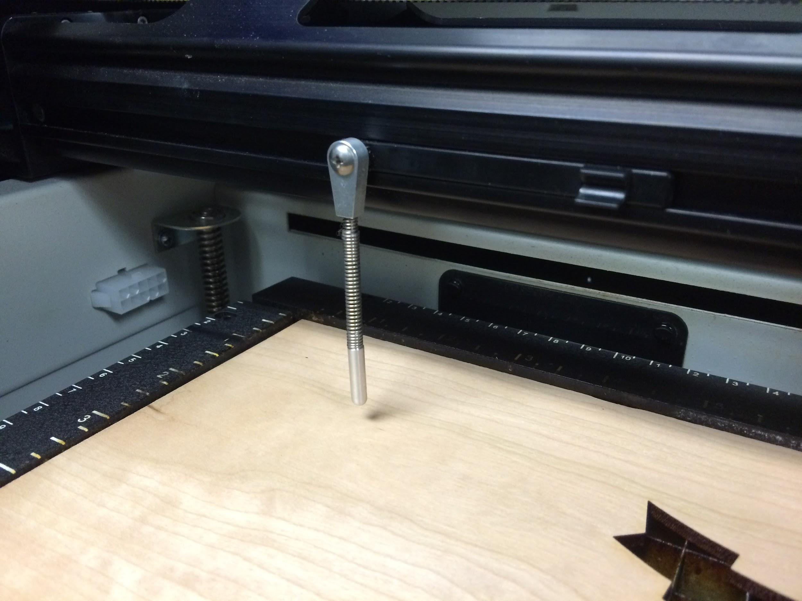  Note:  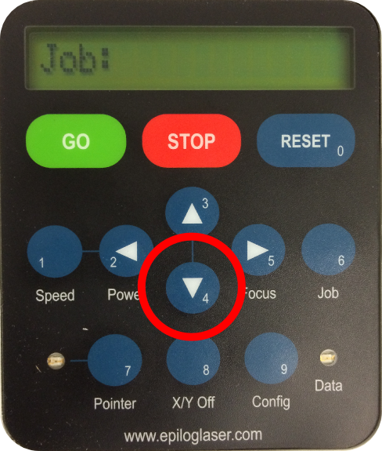
7) Adjust the tray height:  - Press the Up and Down Arrows on the control pad until your material touches the Focus Gauge. If the spring on the Gauge is bent at all, the tray is too high, and you must lower it.  - Lightly flick the Focus Gauge. If it swings freely without touching your material, repeat Step 7a.  If after flicking the Gauge, it swings and briefly and then stops by touching your material, you are at the correct height.  - Replace the Gauge onto the hook, and press the Reset button on the control pad. | 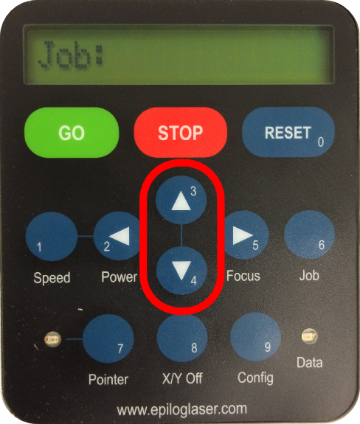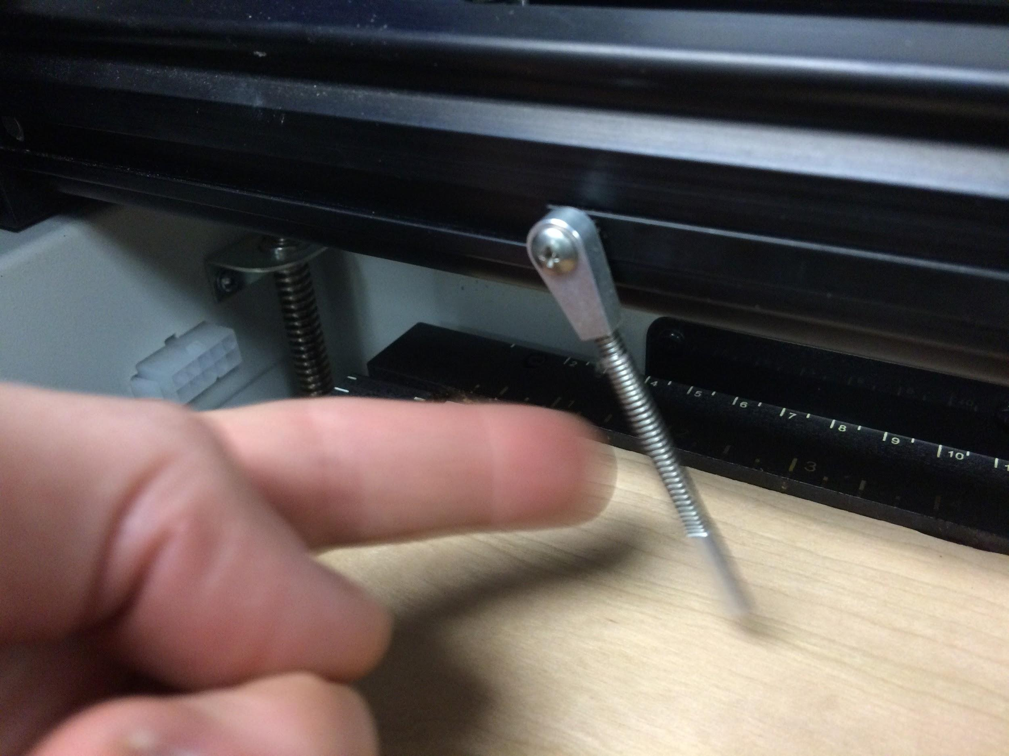  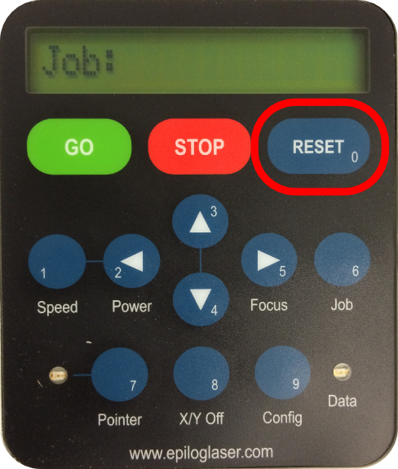
8) If it is not already on, start the computer and log in to ceeostud2.

9) If the computer is not already running in Windows 7 on the virtual machine, select the VMware Fusion application in the dock. | 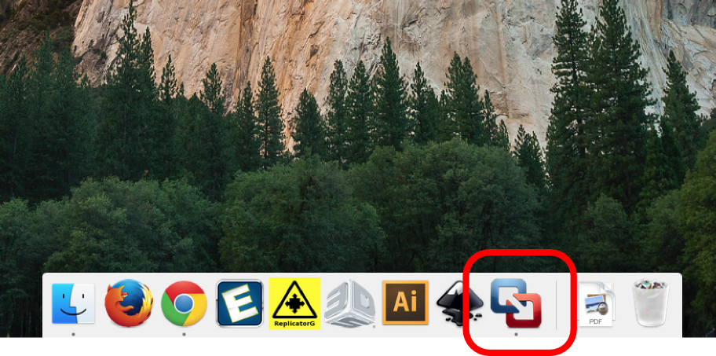
10) If you are importing a file from a flash drive, plug it into the USB hub. When the message show to the right appears, click “Connect to Windows.”  If the message does not appear, hold the mouse at the top of the sceen in VMWare to bring up the menu. Select “Virtual Machine” -> “USB & Bluetooth” and connect your flash drive. | 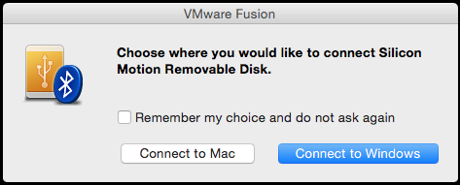
11) Run Adobe Illustrator in the virtual windows 7 machine. | 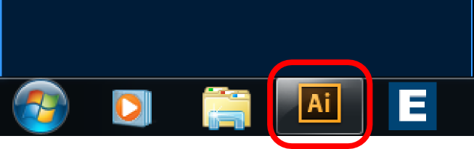
12) Open your file by clicking File > Open.

If you haven’t already done so, make sure your file is properly set up for cutting and/or engraving by following the document below:

Epilog Zing - Doc Setup
13) Click File > Print.

When the Print window appears, make sure Epilog Engraver WinX64 Zing is selected in the Printer selection box.

Then, click Setup at the bottom-left of the Print window.
14) In the new Print window, make sure Epilog Engraver WinXZing is selected, then click Preferences. | 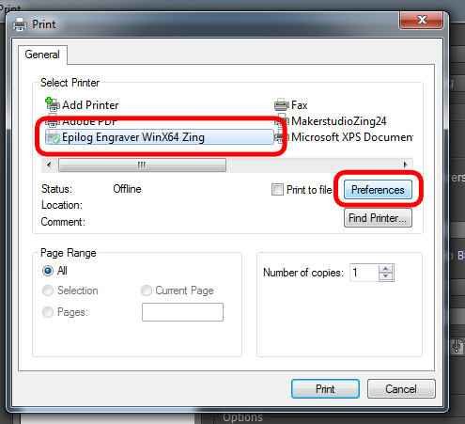
15) When the Epilog Printing Preferences window appears, choose the job type you require:
- Choose the Raster job type if you only want to engrave your material
- Choose the Vector job type if you only want to cut your material
- Choose the Combined job type if you require both engraving AND cutting
16) Refer again to the Speed/Power Settings by following the link below:
Epilog Zing - Speed/Power Settings

Find your material under either the Common or User Submitted Settings.
17) If you will be Engraving (or performing a combined job), find and record the Speed and Power  (Speed#/Power#) under your desired raster resolution, as indicated by the DPI value  (e.g. 500 DPI). | 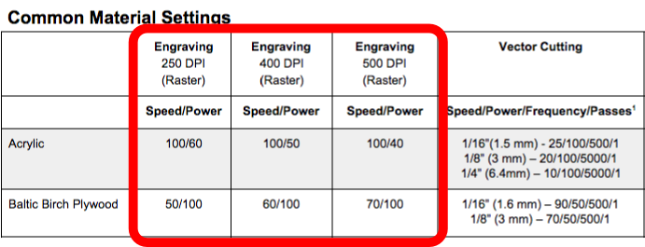
18) If you will be Cutting (or performing a combined job), find and record the Speed, Power, and Frequency (Speed#/Power#/  Frequency#/Passes#) under your your material’s thickness. | 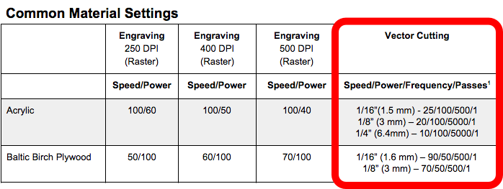
19)Return to the Epilog Printing Preferences window.
If you have chosen either the Raster or Combined job type, select your desired Resolution. This should be the same value as the one used to determine your engraving speed and power settings.
20) If you have chosen either the Raster or Combined job type, set the Speed and Power values to match those you recorded in
Step 17.
21) If you have chosen either the Vector or Combined job type, set the Speed, Power, and Frequency values to match those you recorded in Step 18.
22) Set the Horizontal and Vertical Piece Size (inches) to the corresponding dimensions of your file. If you are unsure of your file’s dimensions you must return to Adobe Illustrator and...  Note: The dimensions of your file Must Not exceed 24 inches horizontally x 12 inches vertically.  When you are done, click OK to finish the print settings. | 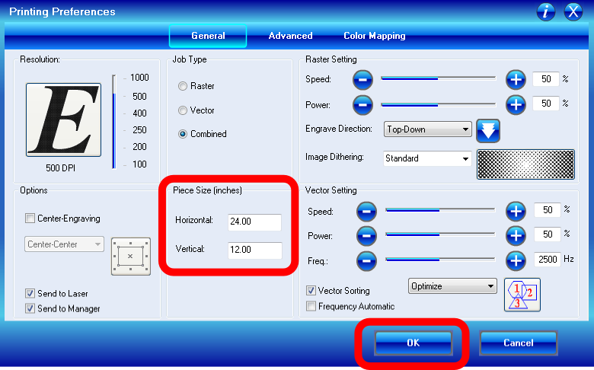
23) Click Print in the Print window. | 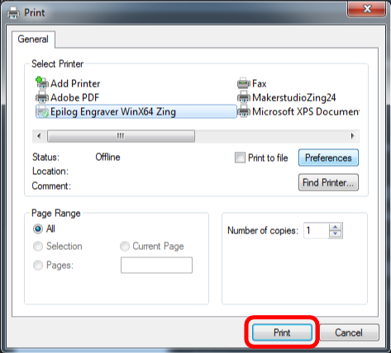
24) Before you start printing, you must make sure your image will be in the correct position.  In the example to the right, there is not enough room in the upper-left corner of the workpiece to fit the current project. There is room, however, in the lower-right corner.  If you encounter this problem, measure the X (horizontal) and Y (vertical) position of the upper-left corner of your available space. Use the rulers on laser’s tray to guide you. | 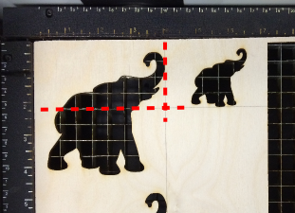  Example:  New Upper-Left Location (X,Y) = (4.25”, 2.25”) will not interfere with any of the pre-existing cuts on the material.
25) In the Adobe Illustrator Print window, adjust the Placement.

If you needed a new upper-left position, as mentioned in Step 24, type the new X and Y positions you just measured.

If you did not need to find a new X and Y position, type in 0.1 in for Both X and Y.
26) Click Print.
27) Close the lid of the laser cutter.
28) Ensure that the Control Pad of the laser cutter displays the name of your file. (You may need to press Job to return to the job menu) If so, you are ready begin. Just press Go. | 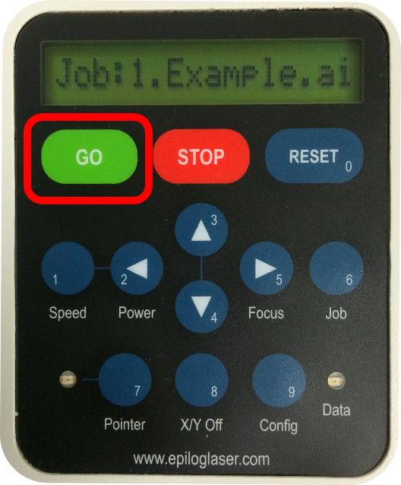
#) After the job has completed, wait about 30 seconds for the exhaust to clear from inside the chamber before opening the top door to retrieve your finished piece.
WARNING: If you have cut pieces, do not move your work piece yet. Tap a few of the pieces without lifting the whole piece. If it has cut all the way through they should move a little.
#) If your workpiece contained cut segments, look to see if they were cut all the way through the material. If not, ……………...

Have some information about how to shut down the machine and clean up - particularly small pieces that fall through the vector grid.

